DATA ANALYTICS WITH TABLEAU

ASSIGNMENT

Task 1: Create one Fixed and One Exclude LOD Expression

Fixed LOD Expression:

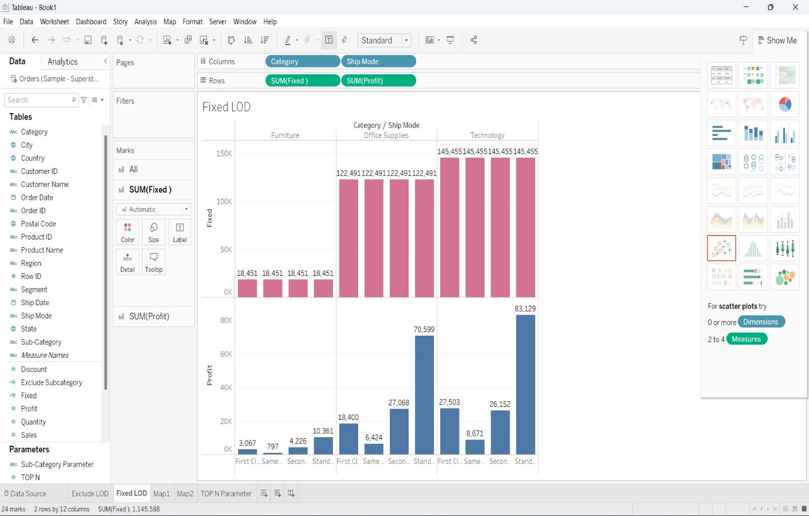

* The above Visualization is a Bar Chart.
* It represents the Fixed LOD Expression.
* For creating this expression, I have used the below mentioned syntax - {Fixed [Category]: SUM([Profit])}
* The above Visualization defines the Sum of Profits for different Categories with their Shipping Modes. And after using the Fixed LOD Expression it is showing us the Sum of Profit fixed for both Categories and Shipping Modes.

Exclude LOD Expression:

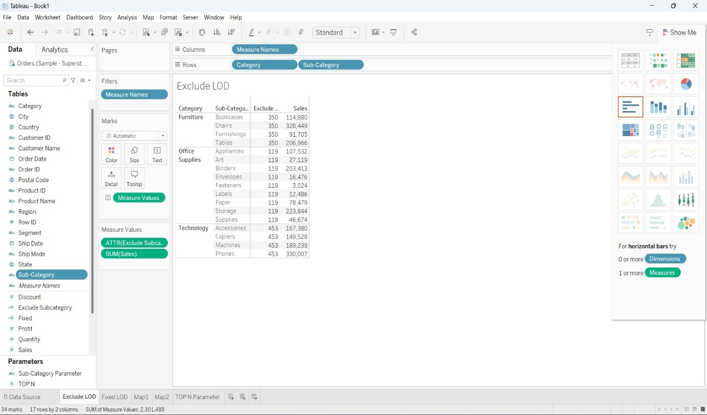

* The above Visualization is known as Text Table Visualization.
* In this Visualization, I have used Exclude LOD Expression.
* For creating this expression, I have used the following syntax:

{Exclude [Sub-Category]: AVG([Sales])}

* The above Visualization shows the Average of sales of Categories and

Sub-Categories. And after using the Exclude LOD Expression it is showing us the average of sales of categories and sub-categories.

Task 2: Create any 2 Map Visualizations using geographical data

Map 1:

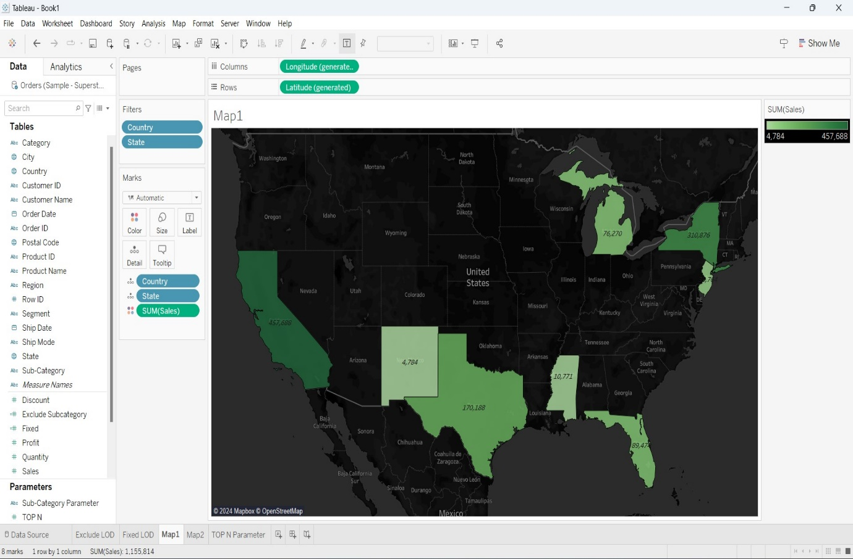

* The above Visualization is Called as Dual Axis Map.
* The country shown in the above map is United States.
* The Visualizations represents the sum of sales of 8- selected states in US.
* The shaded region tells us about the sum of sales and the following texted numbers tells us the sales of that particular region.

Map 2:

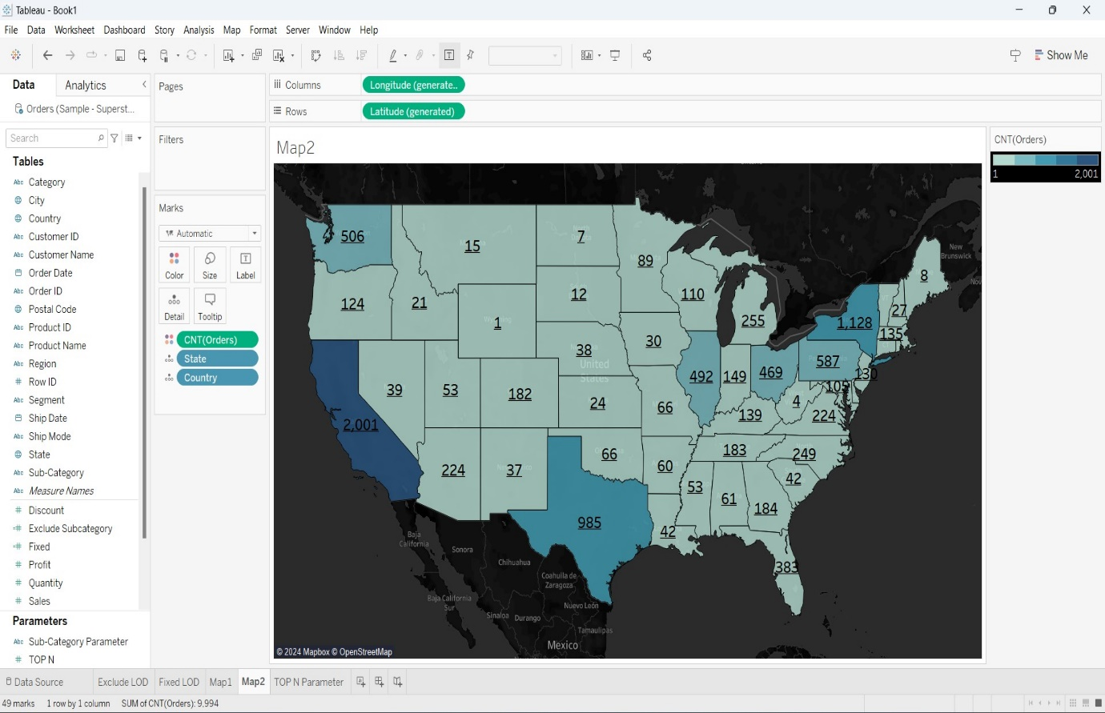

* The above Visualization a Map.
* The country shown in the above map is United States.
* The Visualization represents the Count of Orders of certain States in a Country.
* And the following under-lined numbers represent the count of orders in the country.

Task3: Create TOP N and/or Dynamic dimensions parameters and utilize those in your workbook

TOP N Parameter:

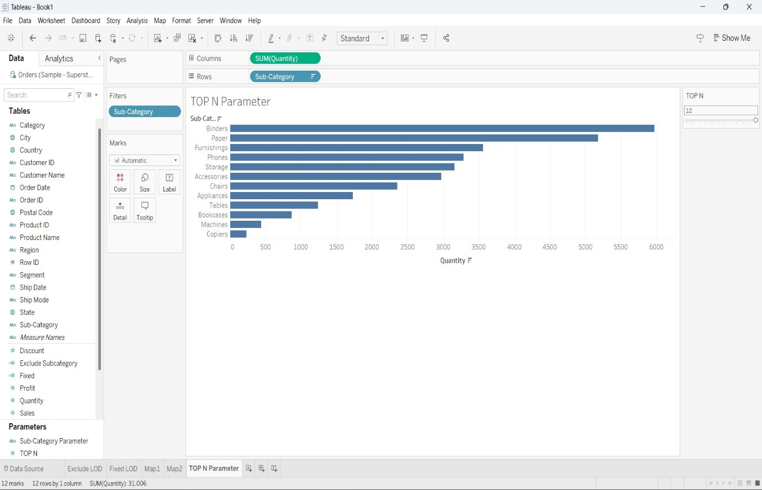

* The above Visualization is known as Horizontal Bars.
* In the above Visualization I have created a “TOP N Parameter”.
* I accessed the values as Lists
* Top 12

Then I used filter to select TOP N Parameter in the top section and selected to show Top 12.

So by observing the above Visualization we can tell that it is showing the Top 12 quantities of sub-categories.